Guided Capstone Project Report
Montana has one of the largest skiable areas in the entire United States of America. Given this it makes sense that Big Mountain Resort brings in about 350,000 customers each year accomodating skiers and riders of all backgrounds and abilities. The resort’s decision to install an addition chair lift to help increase the distribution of visitors recently is testament to the business’s vision for the future growth of the company. However, growth does come at cost. To offset this, we have analyzed various features of the resort in order to make sure that Big Mountain Resort (BMR) is capitalizing on all of its facilities to the best of its ability. We’ve compared our data to the data of other resorts across the country within the market segment. The question we wanted to answer is: How can Big Mountain Resort cut facility costs and/or support a higher ticket price in order to offset the additional operating costs we’ve incurred by next season?
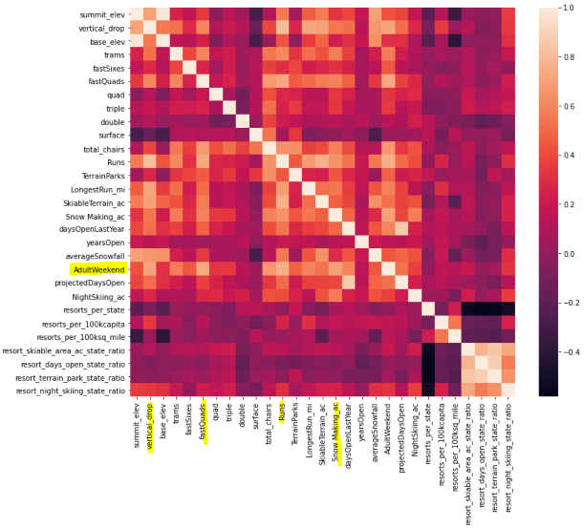
Inspecting the initial dataset, we were able to clean it so we would have the fullest and most relevant information to work off of in order to get the best modelling for pricing. We disposed of missing data as well as focused on just one type of ticket price as we had a differentiation of both weekday and weekend pricing. Having fewer missing data, we worked with the Weekend pricing data for this project. Next we analyzed ticket pricing and how those were effected by the facilities available across all the different resorts across all the different states. This exploration of data led us to pinpoint the top features that most effected the ticket price which were: runs, snow making, fast quads, and vertical drop.

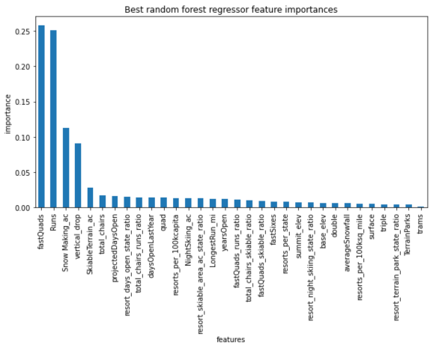
Once we had these features selected, we were able to apply them to our different models. After running through both a linear model as well as a random forest regressor model we found that the latter was the superior model as it produced less variability and the performance tests were consistent with our cross-validation results. Thus, we ran the numbers with our chosen facilities through our selected model, specifically for Big Mountain Resort. According to the model, BMR’s current ticket price of $81 could actually be increased to a price of $95.87 instead. We were also able to apply the potential scenarios that the company had been reviewing for either cutting costs or increasing revenue via ticket prices. Of the four scenarios the best scenarios to add revenue was by increasing the vertical drop by adding a run to a point 150ft lower down but requiring the installation of an additional chair lift to bring skiers back up, without additional snow making coverage, or all the same but adding 2 acres of snow making cover. The model predicted that both those options would support an increase for ticket price by $1.99. Now that we have been able to create an accurate model for ticket pricing for Big Mountain Resort we can use this to make better informed and data-driven business strategies going forward.

